

Name : Gowdham B
RegNo : 23MIS0300
Course Code : ISWE406P
Course Name : Agile Development Process and Devops Lab
Slot : L3+L4
Patient Records Management System
Problem Statement: Ensure patient records are stored and retrieved accurately without data inconsistencies before deployment.
Tasks:
• Develop patient record management logic
• Write JUnit tests for: o Data validation (missing/incorrect fields) o Record retrieval accuracy
• CI/CD pipeline for automated testing and deployment
• Deploy on Kubernetes Real-world relevance: Hospital patient record systems

App.java code:
package com.demo;

public class App {

static class Patient {
int id;
String name;

Patient(int id, String name) {
this.id = id;
this.name = name;
}
}

Patient[] p = new Patient[10];
int count = 0;

public boolean addrecord(int id, String name) {
if (id <= 0 || name == null || name.isEmpty()) {
return false;
}
p[count++] = new Patient(id, name);
return true;
}

public Patient getrecord(int id) {
for (int i = 0; i < count; i++) {
if (p[i].id == id) {
return p[i];
}
}
return null;
}

public static void main(String[] args) {
System.out.print("App is running...");
}

}

AppTest.java code:
package com.demo;

import static org.junit.jupiter.api.Assertions.*;
import org.junit.jupiter.api.Test;

public class AppTest {
@Test
public void validinput() {
App obj = new App();
assertTrue(obj.addrecord(1, "GB"));
assertFalse(obj.addrecord(0, ""));
}

@Test
public void retrieve() {
App obj = new App();
obj.addrecord(1, "HH");
App.Patient o = obj.getrecord(1);
assertEquals("HH", o.name);
assertFalse("PN".equals(o.name));
}
}

pom.xml code:
<?xml version="1.0" encoding="UTF-8"?>
<project xmlns="http://maven.apache.org/POM/4.0.0"
xmlns:xsi="http://www.w3.org/2001/XMLSchema-instance"
xsi:schemaLocation="http://maven.apache.org/POM/4.0.0
http://maven.apache.org/xsd/maven-4.0.0.xsd">
<modelVersion>4.0.0</modelVersion>
<groupId>com.demo</groupId>
<artifactId>test-java-app</artifactId>
<version>1.0</version>
<packaging>jar</packaging>
<name>test-java-app</name>

<properties>
<maven.compiler.source>17</maven.compiler.source>
<maven.compiler.target>17</maven.compiler.target>
<project.build.sourceEncoding>UTF-8</project.build.sourceEncoding>
<junit.version>5.10.1</junit.version>
</properties>

<dependencies>
<dependency>
<groupId>org.junit.jupiter</groupId>
<artifactId>junit-jupiter</artifactId>
<version>${junit.version}</version>
<scope>test</scope>
</dependency>
</dependencies>

<build>
<plugins>
<plugin>
<groupId>org.apache.maven.plugins</groupId>
<artifactId>maven-compiler-plugin</artifactId>
<version>3.11.0</version>
</plugin>
<plugin>
<groupId>org.apache.maven.plugins</groupId>
<artifactId>maven-surefire-plugin</artifactId>
<version>3.2.5</version>
<configuration>
<useModulePath>false</useModulePath>
</configuration>
</plugin>
<plugin>
<groupId>org.apache.maven.plugins</groupId>
<artifactId>maven-jar-plugin</artifactId>
<version>3.4.1</version>
<configuration>
<archive>
<manifest>
<mainClass>App</mainClass>
</manifest>
</archive>
</configuration>
</plugin>
</plugins>
</build>
</project>

Dockerfile code:
FROM eclipse-temurin:17-jdk-alpine
WORKDIR /app
COPY target/*.jar app.jar
EXPOSE 8080
ENTRYPOINT ["java", "-jar", "app.jar"]

deployment.yaml code:
apiVersion: apps/v1
kind: Deployment
metadata:
name: java-app-deployment
labels:
app: java-app
spec:
replicas: 2
selector:
matchLabels:
app: java-app
template:
metadata:
labels:
app: java-app
spec:
containers:
- name: java-app
image: gowdhamb/java-app:latest
imagePullPolicy: Always
ports:
- containerPort: 8080
resources:
requests:
memory: "256Mi"
cpu: "250m"
limits:
memory: "512Mi"
cpu: "500m"

---
apiVersion: v1
kind: Service
metadata:
name: java-app-service
labels:
app: java-app
spec:
type: NodePort
selector:
app: java-app
ports:
- protocol: TCP
port: 8080
targetPort: 8080
nodePort: 30080

Outputs:
Initially after writing the Java code for main file and test file we compile for correcting errors. Once its done we use “mvn clean package” command for creating jar file and also verifying and validating the main and test codes.
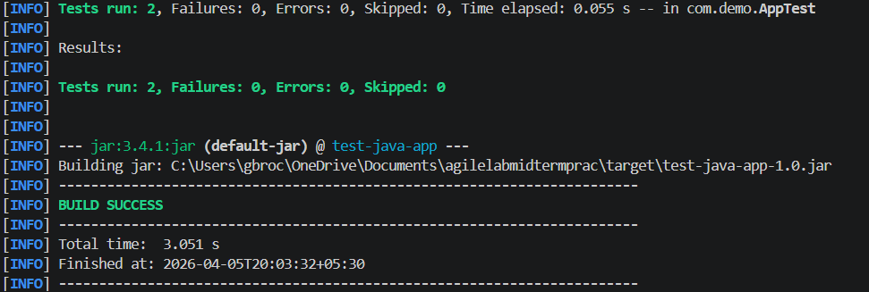
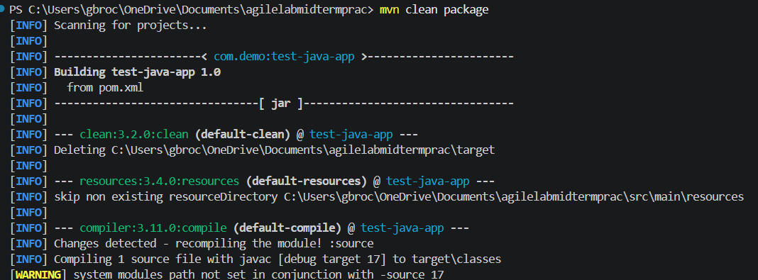

Github

Github:
Now once we get the build success, we push all the codes, dependencies and configuration files into the github repository.
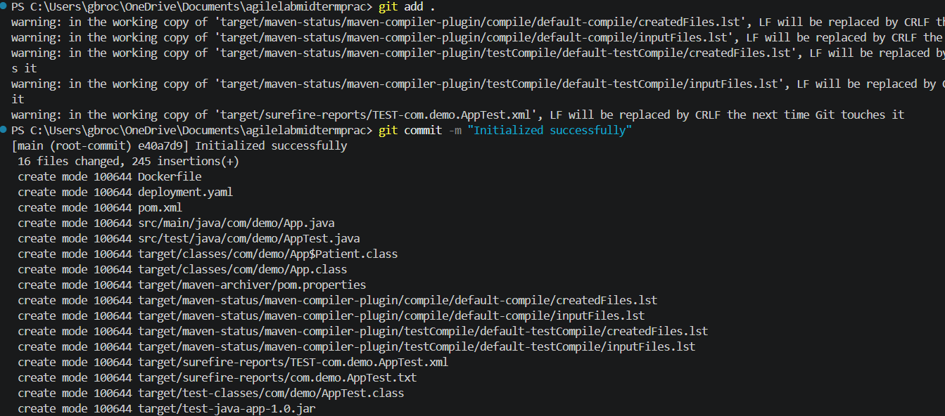
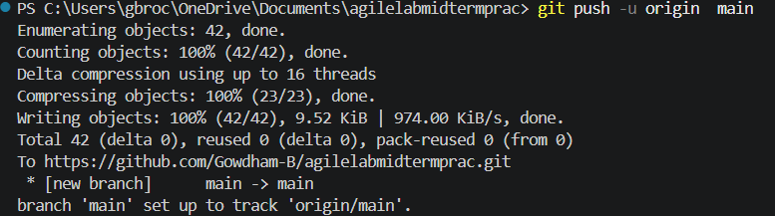

Jenkins:
Once the codes and other files are pushed to the github, we now open Jenkins application and create a job/task named “Java-Full-Scenario” with the option as pipeline. Now we scroll down and we put the pipeline script and save the configuration.

Pipeline script:
pipeline {
agent any
environment {
DOCKER_IMAGE = "gowdhamb/java-full-scenario:latest"
}
stages {
stage('Clone Repository') {
steps {
git branch: 'main',
url: 'https://github.com/Gowdham-B/agilelabmidtermprac.git'
}
}
stage('Build & Run Tests') {
steps {
bat 'mvn clean test'
}
post {
always {
junit 'target/surefire-reports/*.xml'
}
}
}
stage('Package Application') {
steps {
bat 'mvn package -DskipTests'
}
}
stage('Build Docker Image') {
steps {
bat "docker build -t %DOCKER_IMAGE% ."
}
}
stage('Push to DockerHub') {
steps {
withCredentials([usernamePassword(
credentialsId: 'dockerhub-creds',
usernameVariable: 'DOCKER_USER',
passwordVariable: 'DOCKER_PASS'
)]) {
bat """
docker login -u %DOCKER_USER% -p %DOCKER_PASS%
docker push %DOCKER_IMAGE%
"""
}
}
}
stage('Deploy to Kubernetes') {
steps {
bat 'kubectl apply -f deployment.yaml'
}
}
}
}

Now after saving the pipeline script, we run the build now option to automate the docker image creation and deploying the containers in the Kubernetes.
Here itself we have mentioned the required commands to create docker image and deploying the files in Kubernetes. So once the build is successful then it means the Docker image is created and it is deployed in Kubernetes.

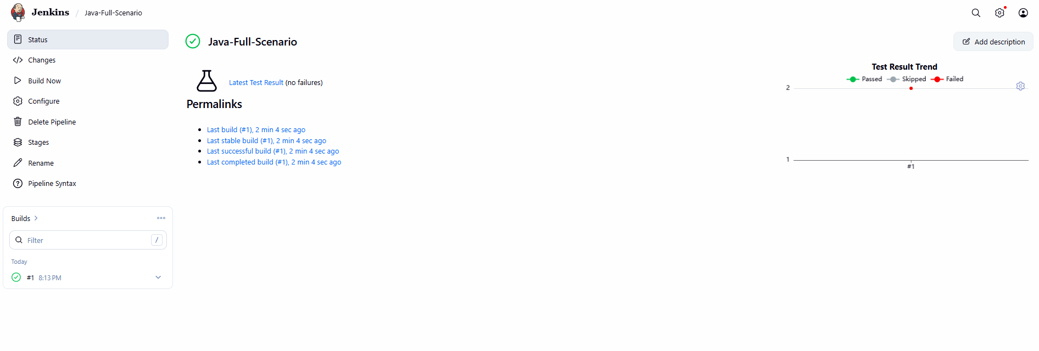
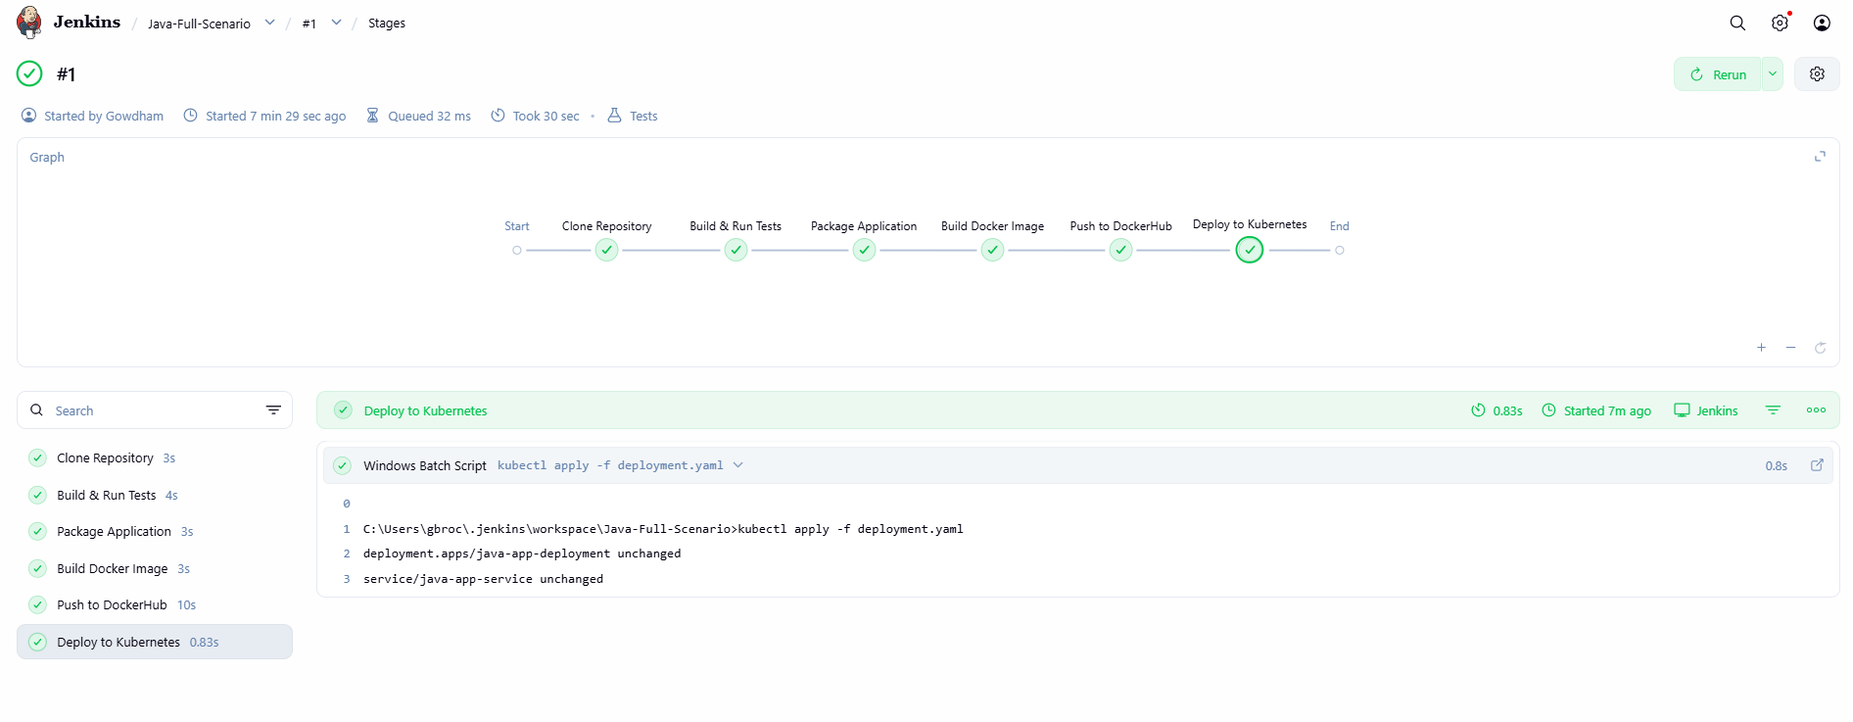

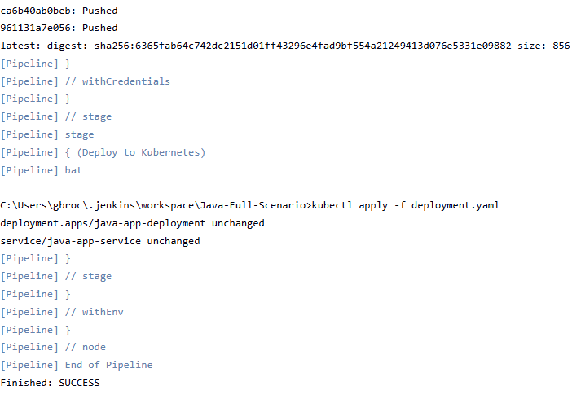

Docker Desktop:
Here in the below image, we can see the created Docker image.
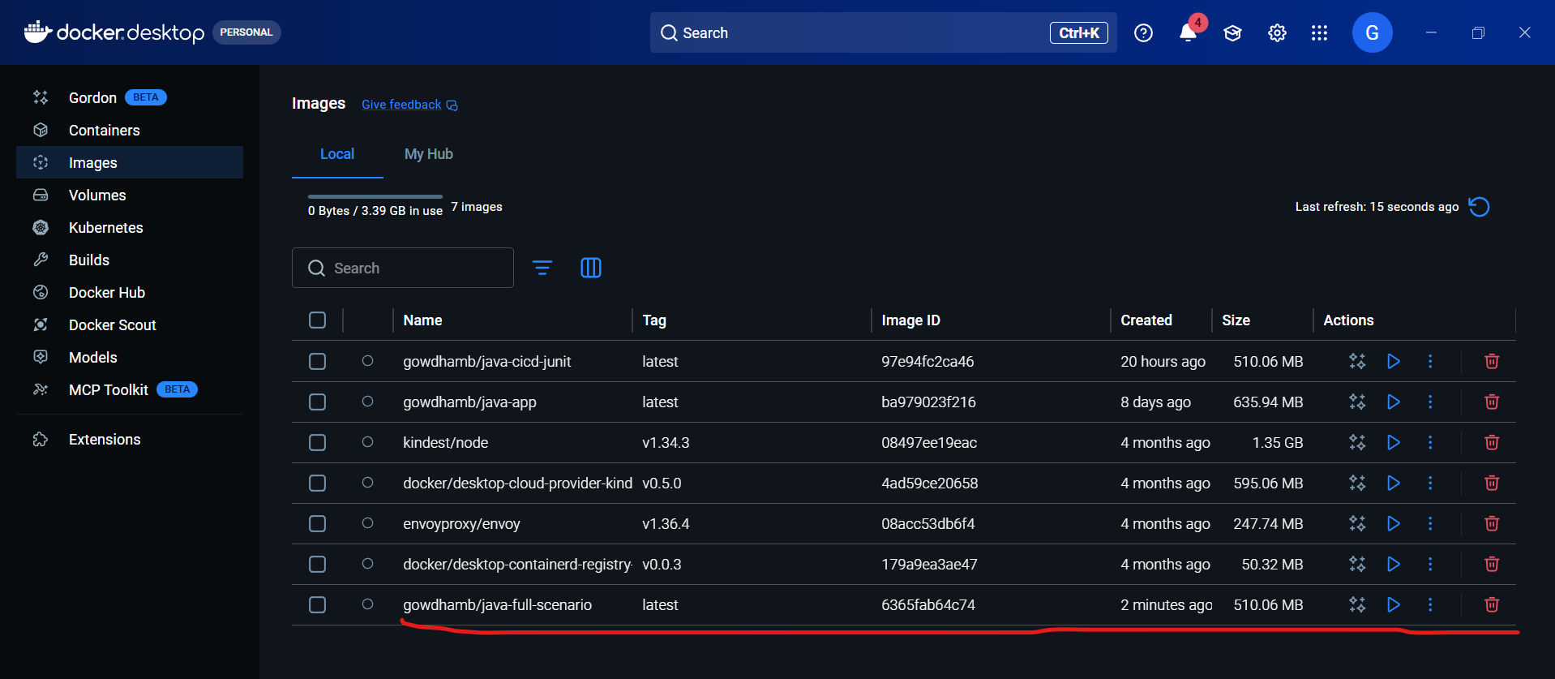
Kubernetes:
Now since the Kubernetes deployment is not accessible through my Docker Desktop, I have used some commands to show the successful deployment of images in the Kubernetes.
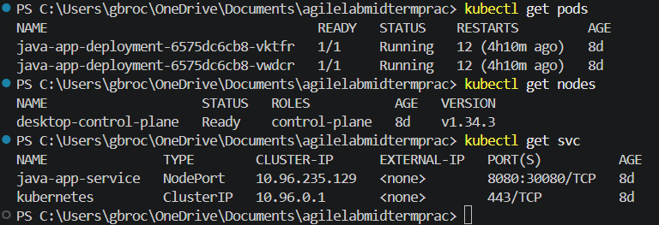

Final report:
Hence the Patient Record Management system is implemented
successfully in Kubernetes through Docker Desktop via Jenkins pipeline.

